AI FitTrack – Personalized Fitness Recommendations powered by AI
Project Design Phase-II
Technology Stack (Architecture & Stack)
Date | 22/09/2026
Team ID | SWTID-2026-5251
Project Name | AI FitTrack
Team Leader: YACHEL C | Team Members: GOMATHI S, ABIRAMI R, JANANI D
Technical Architecture:
The system follows a layered MVC architecture where API clients (Postman, ThunderClient, or a future frontend) communicate with a Node.js + Express backend through REST APIs. Authentication is handled using JWT tokens, all user and workout data is stored in MongoDB, and AI-powered recommendations are generated through a dedicated Google Gemini service layer.
The deliverable includes the architectural diagram below along with the component and characteristic tables.
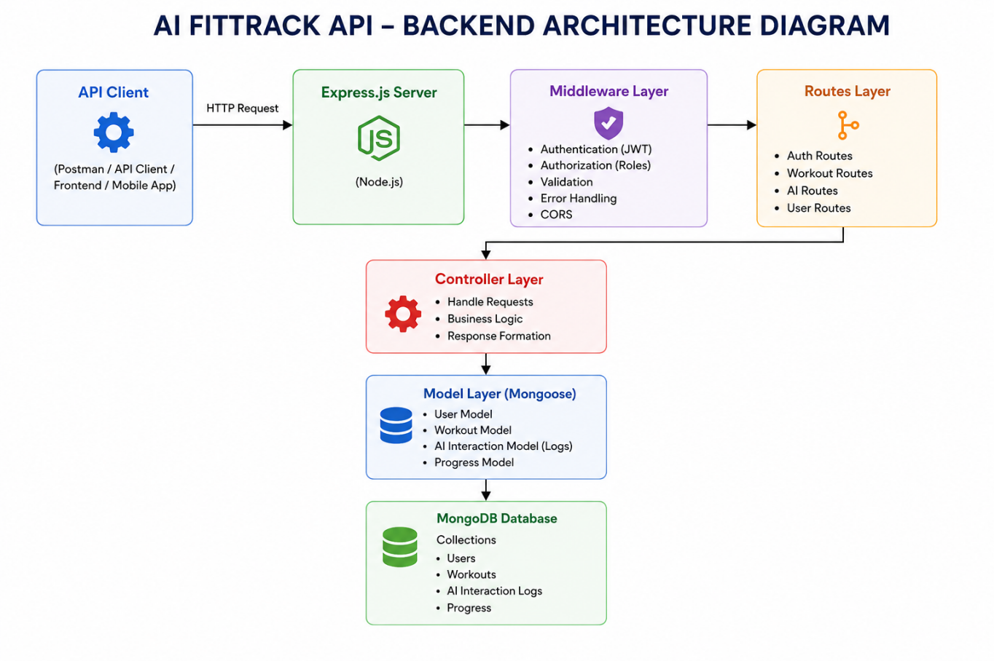
Table-1: Components & Technologies
S.No | Component | Description | Technology
1 | Application Logic-1 | User authentication, JWT token generation and validation | Node.js, Express.js, bcryptjs, jsonwebtoken
2 | Application Logic-2 | Workout CRUD operations and search functionality | Node.js, Express.js, REST API
3 | Application Logic-3 | AI workout recommendation and fitness insight generation | Google Gemini AI, dedicated service layer
4 | Database | Store user accounts and workout data securely | MongoDB, Mongoose
5 | API Communication | Handles secure data transfer between client and backend | REST API, JSON, HTTPS

Table-2: Application Characteristics
S.No | Characteristics | Description | Technology
1 | Open-Source Frameworks | Backend frameworks used in the system | Node.js, Express.js, Mongoose
2 | Scalable Architecture | Modular MVC architecture supporting future features | REST API Architecture, JWT Middleware
3 | Security | Secure authentication and protected routes | JWT Authentication, bcrypt Password Hashing
4 | AI Integration | Personalized recommendations and insights | Google Gemini API (gemini-2.5-flash)
5 | Performance Optimization | Fast, reliable database queries and async request handling | MongoDB Indexing, Async/Await

